FFGLVolume plugin usage

1. First, we need a contrast image. Apply the plugin to the composition (clip, layer). Nothing really changed except the fps.

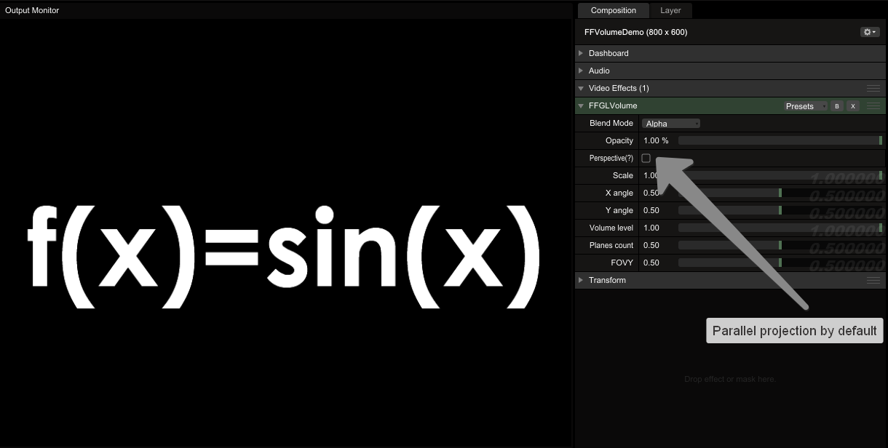

1. Change projection mode. Areas with nonzero luminance forms the volume effect:

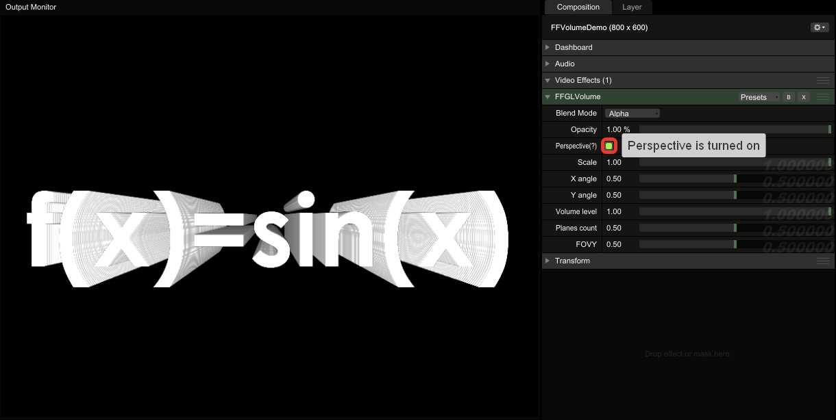

1. You can turn this pseudo-volume along X and Y axis:

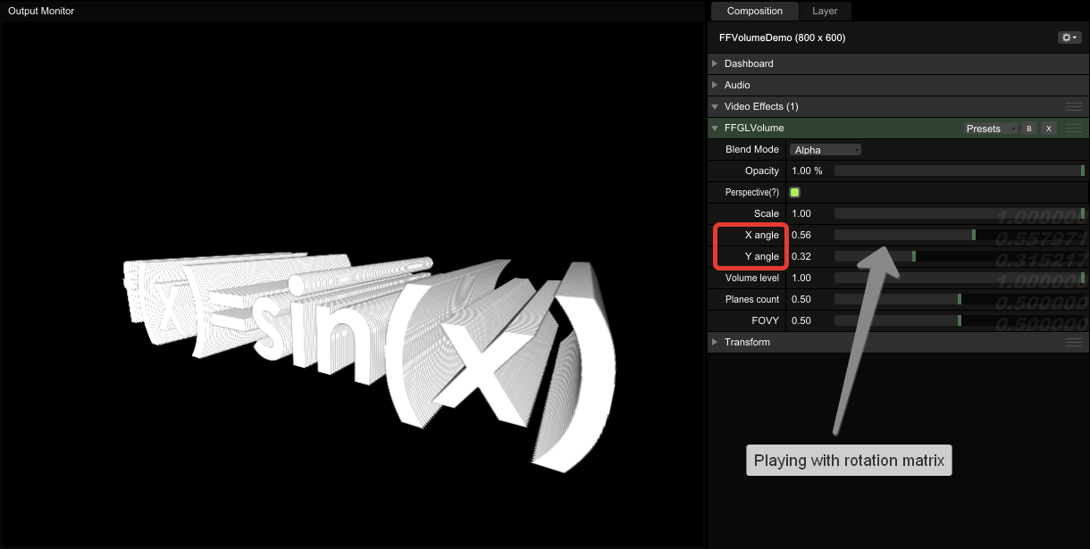

1. Going deeper – setting the number of planes that forms the volume illusion

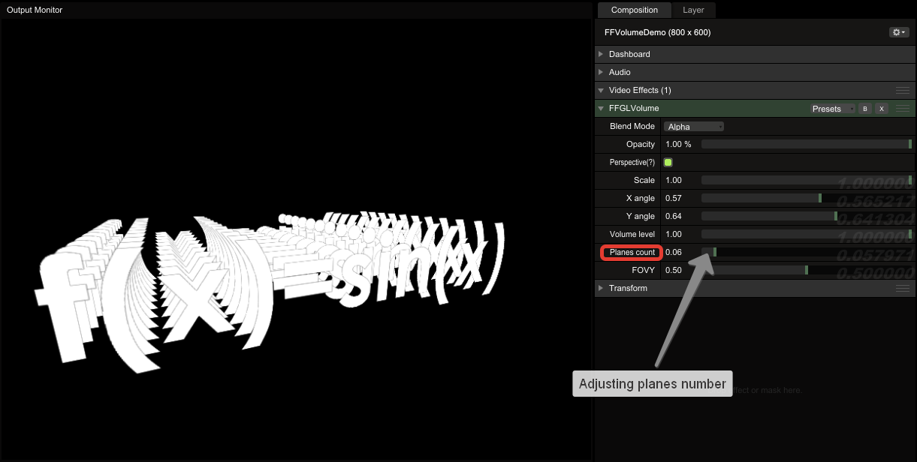

1. Setting volume depth and FOVY (field of view in the Y-direction):

